Development and set-up of a multilingual web portal for EMWIS Technical Unit
Technical design document

Finsiel S.p.A. (Rome, IT) | 
Via Luigi Rizzo, 20
00136 Rome Italy

Table of Contents
0 Introduction 3
0.1 Structure of this document 3
0.2 Field of application 3
0.3 Deviation from PMP 3
0.4 Reference and applicable documents 3
0.5 Terminology 4
1 Requirements 5
1.1 Requirements traceability matrix 5
2 Technical solution 8
2.1 Overall description 8
2.2 Specific functionality 10
2.2.1 Content types 10
2.2.2 Content structure and navigation 12
2.2.3 Content management 15
2.2.4 Multilinguality 17
2.2.5 Search mechanisms 17
2.2.6 Graphical user interface 18
2.2.7 Syndication 20
2.2.8 Thesaurus of terms 21
2.2.9 Notifications on uploads and newsletters 29
2.2.10 Discussion forum 30
2.2.11 Access statistics 30
3 Expected results 32
3.1 Portal toolkit 32
3.2 Operating environment 32
3.3 Software updates and maintenance 33
3.4 User documentation 33
3.5 Technical documentation 33
3.6 Databases interoperability (Oracle, MySQL, PostgreSQL…) 34
3.7 System maintenance & user support 34

Introduction
This document describes the technical architecture used to build the EMWIS multilingual portal and the EMWIS portal toolkit. It aims to provide a clear understanding of the software platform and the functionality that will be made available during the current contract.

Structure of this document
See Table of Contents.

Field of application
Contract | WU Title | WU Code
SEMIDE-Portal2005

This document is meant for the task team involved in the analysis, development, quality and performance testing and acceptance of the software described here.

Deviation from PMP
N/a.

Reference and applicable documents

Code | Title | Date
SEMIDE-Portal2005 | Technical Annex to the Call for Tender issued by the EMWIS Technical Unit under the reference SEMIDE-Portal2005 ; | May 2005
Kick-off meeting minutes |  | Sep 2005
EMWIS Metadata elements (Definitions) |  | Oct 2005

Terminology
EMWIS | Euro-Mediterranean Information System on Know-How in the Water Sector
SEMIDE | Système Euro-Méditerranéen d'Information sur les savoir-faire dans le Domaine de l'Eau
EIONET | European Environment Information and Observation Network
EEA | European Environment Agency
XML | Extensible Markup Language
RDF | Resource Description Framework
SVN | Subversion repository
CHM | Clearing-House Mechanism
EC CHM | European Community Biodiversity Clearing-House Mechanism

Requirements
A set of reference documents are being considered as specifications for the development of the EMWIS portal, toolkit and documentation:
- the Technical Annex to the Call for Tender issued by the EMWIS Technical Unit
- the Kick-off meeting minutes
- EMWIS Metadata elements
- release validation documents

Requirements traceability matrix
The following steps were agreed during the kick-off meeting at Sophia Antipolis on 21 September 2005:
Ref. # | Requirements statements | Deliverable
 | START of the PROJECT - T0 ( 0 week ) | Meeting
 | RELEASE 1 - T1 ( 4 weeks )
 | Technical Design Document (TDD) | Document
 | System infrastructure installed. | SW
[R 4.10] | Content management Panel/GUI | SW
[R 4.10] | Word-like tool content editor | SW
[R 4.10] | Content translation management | SW
 | Three (3) graphical charter proposals  (storyboard & prototype including navigation & templates) | SW/ Document
 | RELEASE 2 - T2 ( 8 weeks )
[R x.x.x] | Portal Home page implemented with chosen charter | SW
[R 4.12.2] | Country template | SW
[R 4.12.3] | Document template | SW
[R 4.12.4] | Projects & Initiatives template | SW
[R 4.12.5] | Partner template | SW
[R 4.12.6] | Publication template | SW
[R 4.12.6] | Publication template | SW
[R 4.12.7] | Resources template | SW
[R 4.12.8] | Thematic folder template | SW
[R 4.12.9] | Private Area template | SW
[R 4.5] | Navigation | SW
[R 4.6] | Sitemap | SW
[R 4.13] | User interface localization (Arabic, French, English) | SW
[R 4.9.3] | News module (online contribution feature available) | SW
[R 4.9.2] | Events module (online contribution feature available) | SW
[R 4.14] | RSS feeds Consuming capacity | SW
 | Integration and implementation document / User’s guide | Document
 | RELEASE 3 - T3 (16 weeks )
[R 4.9.3] | News module ( including Workflow implementation) | SW
[R 4.9.2] | Events module (including Workflow implementation) | SW
[R 4.9.4] | Thematic folders | SW
[R 4.14] | RSS feeds Providing capacity | SW
[R 4.10] | Administration and Configuration Panel/GUI | SW
[R 4.10] | User Profiles Administration tools | SW
[R 4.11] | Metadata integration and indexing tools | SW
[R 4.15.1] | Integration of multilingual thesaurus as indexing keywords | SW
[R 4.15.2] | Binary document (.pdf, .doc,...) indexing capability | SW
[R 4.15.1] | Search engine | SW
[R 4.15.3] | Search result formatting | SW
[R 4.15.1] | Multilingual search mode capacity | SW
[R 4.10] | Private Area management | SW
[R 4.8.2] | Welcome page customization | SW
[R 4.8.1] | On-demand services subscription | SW
[R 4.8.3] | On-demand Push service | SW
 | Diffusion list | SW
[R 4.5] | Print page | SW
[R 4.5] | PDF export page | SW
[R 4.9.3] | Web services Consumer/Provider built-in capacity | SW / Document
[R 4.19] | Performance
 | Setup/Integration document / User’s guide | Document
 | RELEASE 4 - T4 (20 weeks )
[R 4.14] | Forum | SW
 | Crawler function | SW
[R 4.17] | Website referencing
[R 4.16] | Website statistics | SW
[R 4.5] | Extendibility : Ability to plug additional third tiers modules | Document
[R 4.21] | Validation for Unicode/UTF-8 and i18N support
[R 4.21] | Validation for OAI-PHM protocol support | Document
[R 4.12] | Databases interoperability (Oracle, MySQL, PostgreSQL…) | Document
[R 4.7] | Identical Behavior/Display cross-browsers
 | Others features defined in the ToRs | SW
 | FINAL RELEASE - T5 (23 weeks)
 | Website Builder Toolkit + Setup document (English) | SW / Document
 | User’s guide (English) | Document
 | Setup Code source and documentation | Document
 | ON-SITE INSTALLATION & TRAINING - T6 (26 weeks)
 |  | Meeting / SW / Doc.
 | APPROVAL of the FINAL REPORT | Document
 | SYSTEM MAINTENANCE & USER SUPPORT (1 year) | Service

Technical solution
The software support for building the EMWIS portal is based on the Naaya architecture, built on top of the Zope (http://www.zope.org) Web and application server and using Python (http://www.python.org) and TAL/METAL as scripting languages.
Naaya (and its predecessor EWPublisher) are already used in analogous networks: European Community Biodiversity Clearing House Mechanism (http://biodiversity-chm.eea.eu.int) and the EnviroWindows (http://www.ewindows.eu.org). The similarity of the requirements both in terms of user functionality and collaboration especially in the case of the EC CHM makes Naaya to be an adequate candidate for the job.

Overall description
Naaya is a multilingual web content management system that allows users with all kind of backgrounds to administrate various aspects of a portal, with respect to their privileges and areas of expertise (content contributors, validators or managers, technical or non technical administrators, translators, etc.).
User friendly
Non-technical users can easily create and manage content using features like the integrated WYSIWYG editor. Complete content management functionalities are available: cut/copy/paste, delete, submit/approve/validate content, edit, translate, check-in/edit/check-out of single items.
Multilingual support
The interface can be translated in one or more languages, the content (e.g. folders, news, files, HTML documents, URLs, events) is also multilingual and the syndication model is language-aware. Multilingual searches can be performed internal or across a network of portals.
Skinable
Interchangeable layouts can be defined by managers, each one having one or more colour schemes. Such feature is possible due to the separation of the content (data), logic (functionality and behaviour) and presentation (layout) layers made in Naaya. Web designers can make use of just cascade style sheets and images to define new schemes.
Workflow and version control
Built-in workflow process ensures the content provision and maintenance, delegation of authority and data quality assessments. Files uploaded in a Naaya portal have support for storing old versions for future consultation.
Syndication
Powerful syndication tools expose the local channels of data and grab remote ones; export of content in RDF -based formats (channels such as latest uploads, latest news, content of folders, etc.).
Import/export
Easy import/export of the content can be done using a proprietary XML format - useful feature when it comes to migrating data from sites built under different platforms into Naaya (e.g. relational database and PHP to Zope). Also, Zope's native import/export facility (zexp files) is available to transfer data from one Naaya portal to another. Due to the use of XML, the migration is independent of the operating systems or technologies used.
Users and security
Naaya comes with a powerful user/roles/permissions management system. Enhanced user credentials are kept, along with the possibility to plug different user sources (LDAP, MySQL, etc.). Certain areas of the website can be protected from usual visitors and browsing rights can be granted to certain groups of users.
Easy to setup and upgrade
Installation kits for Windows and Linux platforms are available. You can have an out of the box portal with a full content management system running on your computer in just a few minutes.
Upon release of future Naaya versions, administrators can easily upgrade their portals maintaining the data integrity.
Standards used
All pages are XHTML 1.0 Transitional (http://www.w3.org/TR/xhtml1/) compliant and the style sheets are using CSS2 Specification (http://www.w3.org/TR/REC-CSS2/). In terms of accessibility, the Web Content Accessibility Guidelines 1.0 priority 2 (WAI-AA) is followed for the user interface and priority 1 (WAI-A) for the administrative forms (http://www.w3.org/TR/WAI-WEBCONTENT/wai-pageauth.html).
Modular and flexible
The Naaya architecture is built as a core set of generic products to which custom components can be developed and added to fit the needs of a particular organisation or network.
Due to the modular structure of Zope and the flexibility of Naaya, additional functionality (e.g. calendars of events, notifications of uploads, forums, issue trackers) can be added on top of the content management system at any time; this is done by taking any plug-and-play Zope product and installing it on that server.
Technical details
Naaya is developed as a set of reusable plug-and-play products for Zope that allow the creation of multiple websites within the same Zope server, all benefiting from the same functionalities, but independently customisable. This feature decreases the deployment time usually requested for such a procedure and allows instant creation of new independent sites within the same server installation.
Naaya is written in Python, a powerful open source object oriented programming language. Python can be used to add new functionality to Naaya or to bring changes to the existing architecture. Naaya stores all the data in Zope's built in transactional object database ZODB. The presentation part is coded using the TAL/METAL tag-based scripting languages.
Naaya runs on Windows, Linux, BSD, Mac OS X, and many other platforms supported by Python.

Specific functionality

Content types
The content types provided by Naaya portals by default are generic ones:
- news item – announcement with a short period of relevancy;
- event – contains data about a meeting, conference, etc. such as the begin and end dates, location information, contact information; the events can be presented in a calendar form;
- story – headlines interesting for the website’s area of expertise, usually containing pictures, meant to be published on the front page and confer the website a dynamic look;
- folder – container for other items; the same concept from the operating systems;
- file – item capable to store any type of file and also keep old versions of it if necessary;
- document – common HTML page, built by the content contributors using a WYSIWYG editor;
- URL – link to a web resource external to the portal; using a link checker, broken links can be individuated automatically and fixed by the content managers;
- pointer – link to a web page from the very portal, therefore avoiding publishing and maintaining twice the same data;
- media file – special type of file which uses browser’s plug-ins to display short films in a web page, without needing to download it and use a multimedia player to view it on the local computer;
- photo – image object that handles the adequate display and fast rendering of various types of pictures.
All Naaya content types are pluggable, in the sense that:
- managers can uninstall a subset of them after a portal creation, in which case they will not be available for use inside that website;
- programmers can create new ones and place the Python class along with the corresponding add/edit and index forms in the specific folder from the NaayaContent product and managers can import and use them into a Naaya portal.
New types (templates) will be created for EMWIS following the indications given in TORs for the attributes, behaviour and default layout:1
- Country – folderish object, used to store and present information related to each participant in the ‘Countries’ top-level folder of the site
- Project – non-folderish object holding information on water-specific initiatives\
- Document – folderish object, with a predefined structure of documents, photos, databases, glossaries and thesauri
- Projects & Initiatives – folderish object , used to store and present information inside the ‘Initiative & Projects’ top-folder from the site
- Publications – non-folderish object, used for the handling of press items in the ‘EMWIS Publications’ top-level folder from the site
- Thematic folder – folderish object, used inside the ‘Resources’ top-level folder from the site
- Resources – folderish object, used to store various types of resources
- NFP Private Area – folderish object, used as a restricted space for document sharing among NFPs
- Multimedia photos – folderish object, container for photos
All Naaya content types have a common set of properties (metadata), a custom set of properties which defines the specific behaviour and presentation and a dynamic set of properties which can be defined on the fly for each portal installation at any time with immediate propagation throughout existing instances. This will also apply to the newly created templates enumerated above.
Also, the new content types will inherit the default behaviour of the default ones: publishing workflow, content management features, multilinguality, syndication, WYSIWYG editor to help non-technical content providers build HTML parts of pages, inclusion in the search mechanism, etc.
In the case of folderish objects that have special requirements for their presentation which overwrite the default folder presentation (listing of the subobjects), the content management part will appear when properly authenticated as content contributor, administrator, etc.
The custom views of various types folders usually involve:
- a particular left-side portlet with listing of the relevant sub-objects, whether they are folders, files, search forms, etc.
- a different heading presentation (the default folder heading is the title of the current folder) and
- a set of predefined right-side portlets (e.g. latest 5 news relevant for that area, 5 upcoming events relevant for that area)
The possibility to define custom single indexes for folders in Naaya websites will be used to accomplish such task.
Below there is a screenshot of the anonymous view of the ‘Countries’ folder and one from the same form accessed by an user authenticated as Administrator:

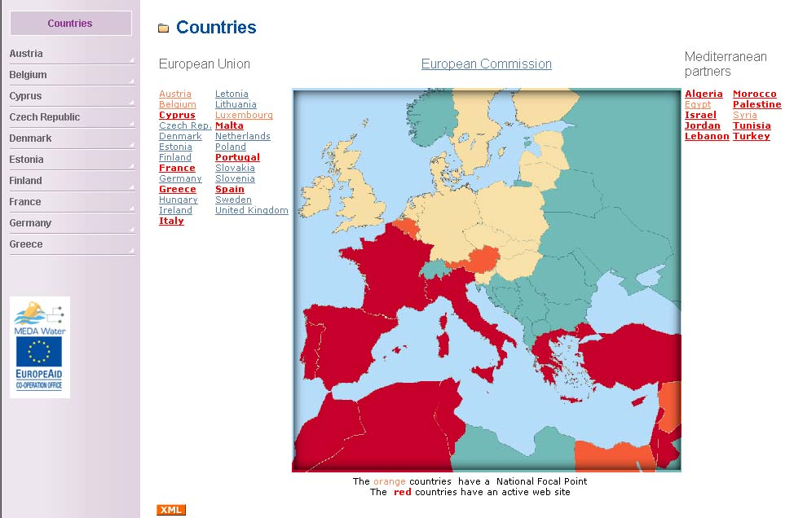  Anonymous view | 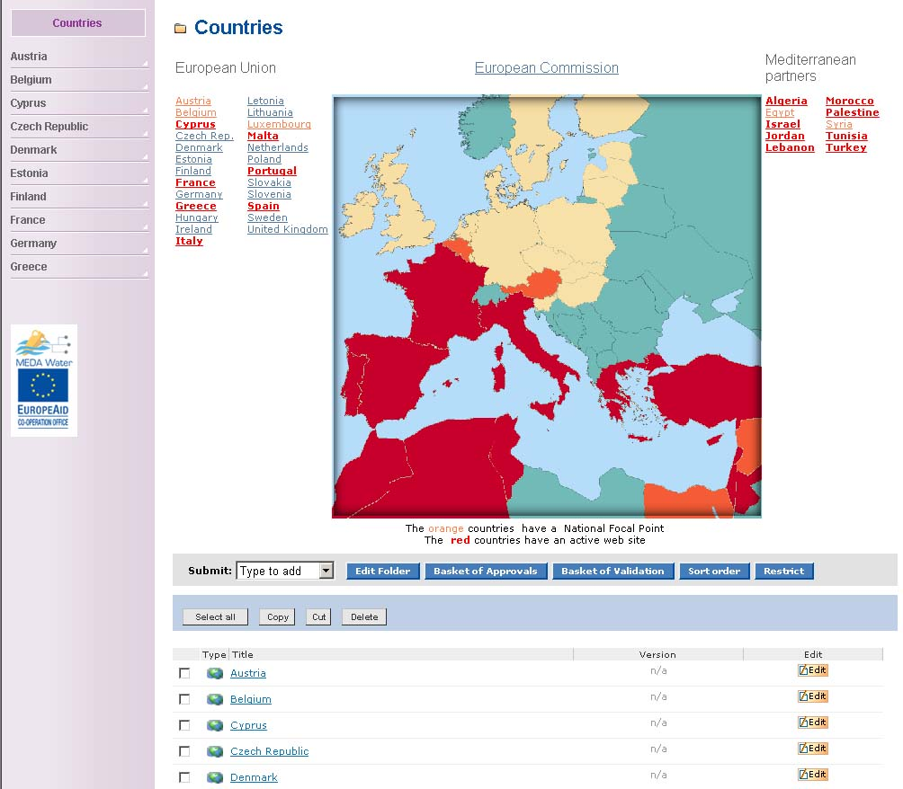  Administrator view

Some of the existing data types – news and events – will be modified to accustom the EMWIS network requirements in terms of properties needed and their mandatory status. The labels and wording on the web forms will also be changed where necessary, in order to comply with the specifications from TORs.
The metadata elements for each type will be taken under consideration and the necessary modifications brought to data in order to comply with the EMWIS specifications (“EMWIS Metadata elements” document).

Content structure and navigation
The data throughout the portal will be organised in top-level folders with different views and default structure. The left-side portlets for those folders present the hierarchical structure from that point on two or three levels.
Quick access to the archives of news and events and to the rest of the portal hierarchy on two levels will be offered to end users from each portal page. The link to the sitemap will be also easily accessible so users have the overall view of the (relevant) website structure:
ABOUT THE SITE
Site map
Copyright & Disclaimer
Webmaster
Contact us
FAQ
What's new?
Statistics
COUNTRIES
INTRODUCTION
Euro-Med partnership
Mission
Themes
Organization
Activities
PARTNERS
RIOB
IME
GWP
SPONSORS
CEDEX
OIEau
SOGESID
European Commission
INITIATIVES & PROJECTS
Database
MED EUWI
About Water Initiative
Objectives
Geographical Area
Steps
Documents
Actors
MEDA EAU
About MEDA Water
Objectives
Geographical Area
Projects (list)
Steps
Documents
DCE
About the Water Framework EC
Common strategy
Steps
Objectives
Documents
Legislation
Examples (drop down list)
INCO MED
About INCO MED
Objectives
Geographical Area
Projects (list in a dropdown menu)
Steps
Documents
LIFE
About LIFE
Objectives
Geographical Area
Projects (list in a drop down menu)
Steps
Documents
SMAP
About SMAP
Objectives
Geographical Area
Projects (list in a drop down menu)
Steps
Documents
EMWIS RESOURCES
News
Forums
Agenda
Thematic directory
Search
EMWIS PUBLICATIONS
EFlash
Newsletter
Leaflet
Communication plan
Press Corner
Press releases
References
Specialized Press
DOCUMENTS
Key documents
European legislation
International conventions
International norms
Database
Glossaries
Thesaurus
The top-level folders (main topics) are listed on a navigation bar accessible from all pages for quick access. Since these folders are part of the site content, they will be translatable in all available languages and the translation will be displayed to end users according to the language of their choice.
The ‘Quick access’ dropdown box present on the heading area of each page contains a list of links (set by the administrators from the corresponding administration form) for end users rapid access to some of the site resources. These links will be translated from the translation centre – also part of the administrative area.
Another navigational aid is the breadcrumb trail, always present above the main content of the page. It enables users to go back in the folder hierarchy from the point they reached up to the site root (home page).

Content management
Based on different roles they are granted, users can execute the following content management functions through friendly web forms:
- submissions of single data types; WYSIWYG editor is available for all fields that allow HTML content (e.g. the description); the submissions made by users that do not have publishing rights are not immediately available to the public, they need to pass a content manager approval first;
- review and approval of single items which results in immediate publishing of those;
- editing of single data types, using the same fields’ format and layout as for the submission forms;
- check-out/check-in of single data types; this operation allows content managers to edit an item in several steps, save the changes after each step and commit/discard the changes only when they are sure of the result; in the time between the check-out and commit operations, the data remains the same for the end users since the content manager works on a version of the content;
- delete of a set of items from a folder;
- copy/cut/paste operations for all types of data;
- validate single items; these operations result in a periodical quality check performed on the information published in the website when this information might become obsolete; the users performing such operation do not have rights to make modifications on the published data so they can mark the data as:
  - validated OK
  - not OK, in which case they must add a comment suggesting ways to update the old information;
After the validation process, content managers have a friendly web form which lists the items that failed validation, list the Validators’s comments and have direct access to the editing form of the single items so they can perform the necessary updates.
The default content management workflow that can be tailored according to future needs is presented below:
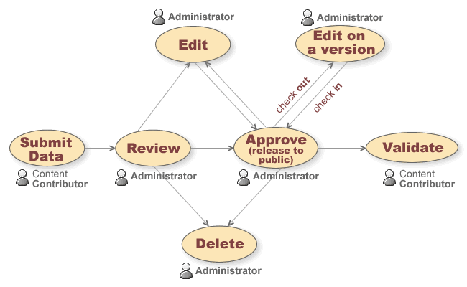

Multilinguality
The Naaya portals are multilingual in the sense that:
- the administrators can define the list of languages that end users will be able to choose;
- all pages are encoded in UTF-8, which means all characters from all languages are supported;
- the content can be translated in all the available languages by content managers suing friendly web forms;
- the layout can be also translated by accessing the translation centre available from the administrative area;
- the different channels generated from the postal are language-aware, meaning that their content is only given in the chosen language; this way,
- searches are performed in the language selected by the user;
- localization is ensured based on: system or browser settings, specific URLs (adding the code of the desired language in the URL results in the change of the active language used), etc.
In order to change the list of available languages, Managers should enter the Zope Management console of the website, access the portal_properties object from the corresponding ‘SEMIDE site’ and open the ‘Languages’ tab. This form allows adding/deleting languages and re-indexes the existing content and translated interface accordingly.

Search mechanisms
An internal search mechanism is built-in Naaya portals, based on the indexing and cataloguing of all data types present. To be noted that this mechanism is also searching inside the uploaded files such as PDF, Word, Excel.
Currently, the search facility can only display results based on a free text search, but it will be refined to include further filtering such as choosing a location in the portal where to search, what types of content to find, choosing thesaurus keywords, etc.
The simple search will return results found in the translations of the content in the language previously selected by the end user. For instance, if a French phrase will be searched when the language selected is English, there could be no results returned even if the phrase might appear in the English translation some items.
The advanced search will allow users to select multiple languages when searching.
Optionally, an external search facility can be linked for searching across multiple portals of the same network (see section Syndication for more details).

Graphical user interface
The Naaya platform was developed ensuring the complete separation among data, presentation and business logic. This approach allowed the creation of different graphical layouts, each one having one or more colour schemes without interfering with in the information published in the portal or with its behaviour.
For each portal a new layout can be created or existing ones can be used and just the colour palette can differ. This implies the definition of a set of standard elements that appear on every page (e.g. the search bar, the navigation breadcrumb trail, the listing of a set of links, etc.), the way these are presented using style sheets and how these are arranged (top, left side, footer, etc.).
When planning a new layout, modern design standards are taken under consideration, such as:
- accessibility of the information towards all users (including users with disabilities), all target medias (different browsers, PDAs and mobile phones, TVs, speech synthesizers, Braille interpreters, TVs, printers, etc.) and search engines
- usability standards
- modern markup (XHTML, CSS2, SVG)
A default layout will be delivered for the EMWIS portal and toolkit, with 4 colour schemes to be used for national installations to ensure both branding and diversity.
The following picture is the generic page template based on the Finsiel proposals and on the EMWIS team comments; to this further modifications can be brought at a later time as feedback is received from the stakeholders or specific requirements that might be revealed during the developments ask for:

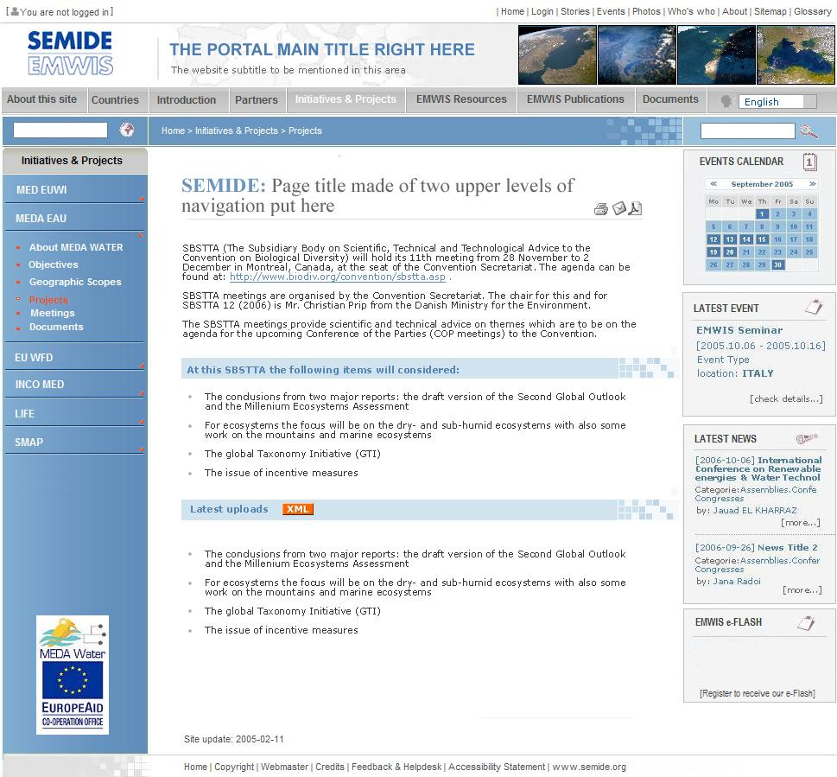

Three colour schemes are available for the EMWIS website, among which administrators can choose from the “Portal layout” form of the administration centre.

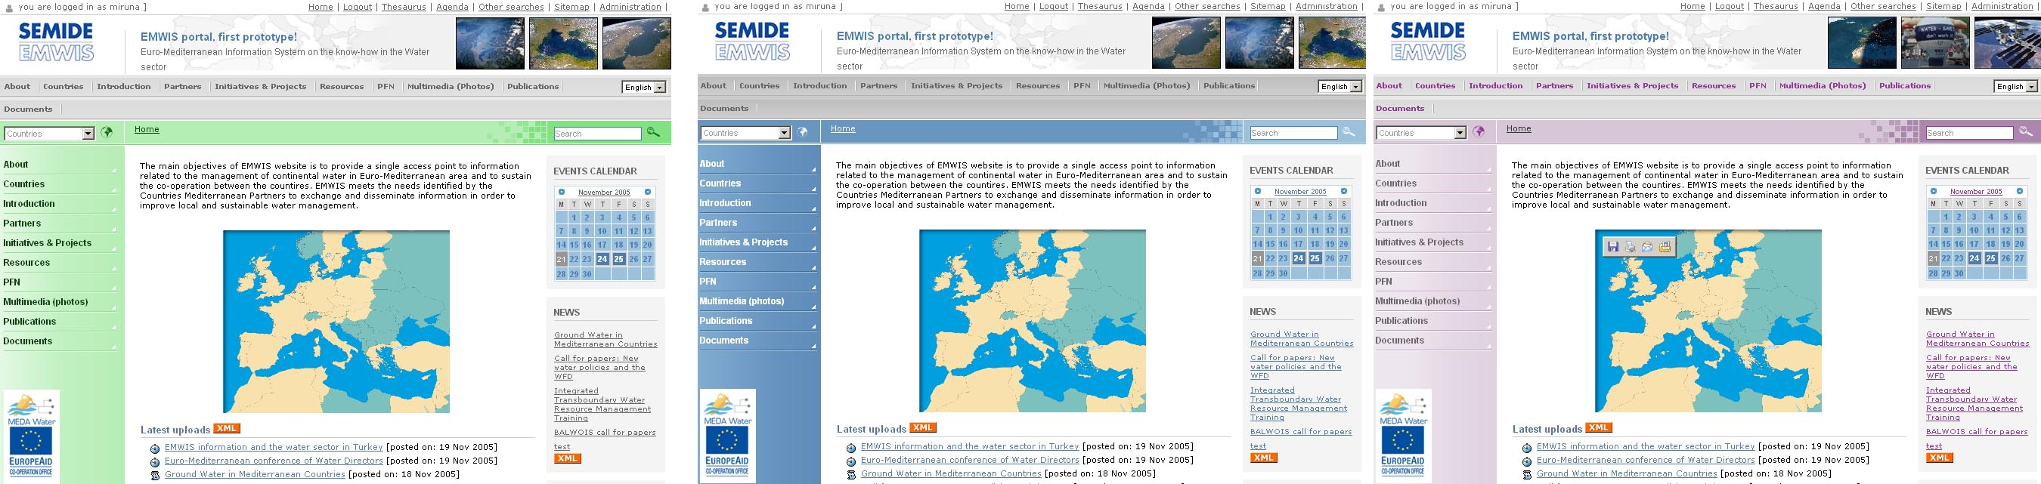
The site header contains a logo image on the left side and a set of images on the right side, dynamically chosen from a list of thumbnails (considering the Arabic layout is a mirror of the existing ones, the right and left sides are swapped when the selected language is Arabic). All this pictures can be changed from the administrative area:
- Portal properties -> Logos tab allows administrators to change the left side logo
- Header thumbnails form allows administrators to upload/delete pictures in the archive from which the thumbnails are rendered

Syndication
In order for the portal information to be correctly transmitted and picked up to/from remote websites and search engines, it is automatically exported in XML formats, starting from the simple RDF form on to dedicated extended formats. The same approach is used for harvesting data from remote sources.
All the necessary mechanisms are included in Naaya so that administrators can easily:
- define and describe the relevant channels in their portal in different languages; the URLs of the channels individuated this way can be then publicly advertised so that other websites can use them to display the headlines on their pages;
- pick up remote channels and publish them in the local portal based on language, type, area of interest (e.g. latest news from a related organisation’s portal).
The data harvested from remote sources is automatically updated on regular basis by the system.
The local channels in RDF format are generated upon each HTTP request. Their content depends of the language selected in the user’s browser or on the language parameter given in the URL. For instance, if someone tries to get the latest news in RDF format in French, the latest 5 news translated in French will be included here; even if a more recent item might be published, let’s say, only in English, it will not be included in the channel.
Whenever in the website RDF channels are available, the syndication (XML) picture will appear which links to the corresponding RDF file.
A network registry can be installed centrally (on the EMWIS site) to harvest and display information on the channels offered by each participant to the network. Such application allows administrators to define the sites which are part of the network, and their exposed channels are automatically harvested on regular basis or can be manually entered also by administrators if the remote websites do not implement the same technology.
Based on the local channels manually defined, Naaya portals automatically generate an RDF file in the root folder called localchannels_rdf which has metadata about the portal and its channels. Below there is an example of such file:
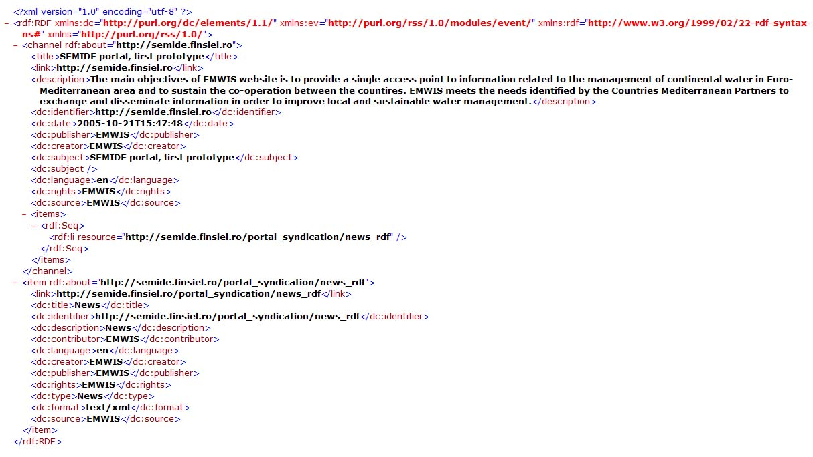
The definition of the portals that form the network is not only useful for syndication reasons, but is also used in the network search, which allows searching free text in all websites that implement the Naaya functionality and display the results on a single page.

Thesaurus of terms
Specialised multilingual glossaries can be added in Naaya portals for the harmonization of metadata fields such as keywords and coverage. This is useful for the data published in such a portal in order to be properly categorized, indexed and searched.
Depending on the areas of interest covered by such a portal, the terms associated with the various data types can come from biodiversity glossaries (the case of the Clearing House Mechanism websites), the agreed EEA’s environmental glossary for the EnviroWindows network, etc. The picture below presents an editing form for a file where keywords can be added from an environmental glossary:
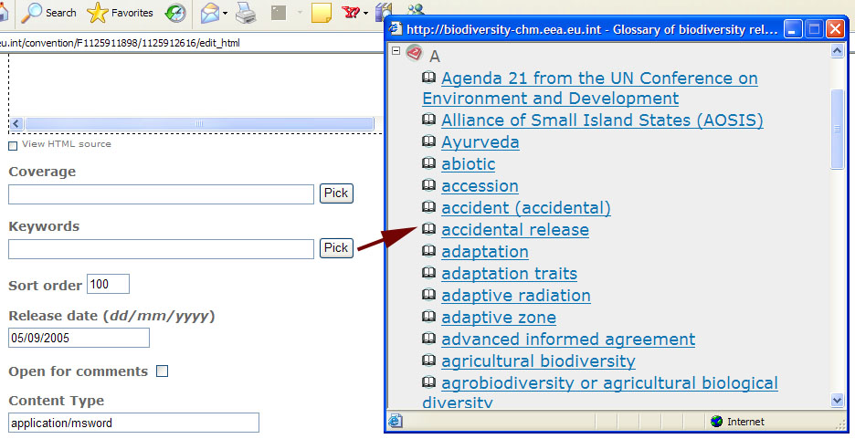
XML/RDF/SKOS import/export procedures allow the transfer of glossaries’ data from one or more existing sources to a Naaya portal.
The support for holding glossary terms and structure in Naaya is currently the NaayaGlossary product which will be replaced for the EMWIS portal and toolkit with another software component for storing, querying and accessing multilingual thesauri.
The new Zope product is called NaayaThesaurus and it uses Python to create structures similar to the ones held by an external relational database. Such architectural choice keeps the access time to thesauruses content low and eases the distribution package installation and maintenance.
The UML model used for the content storage in NaayaThesaurus is presented below:
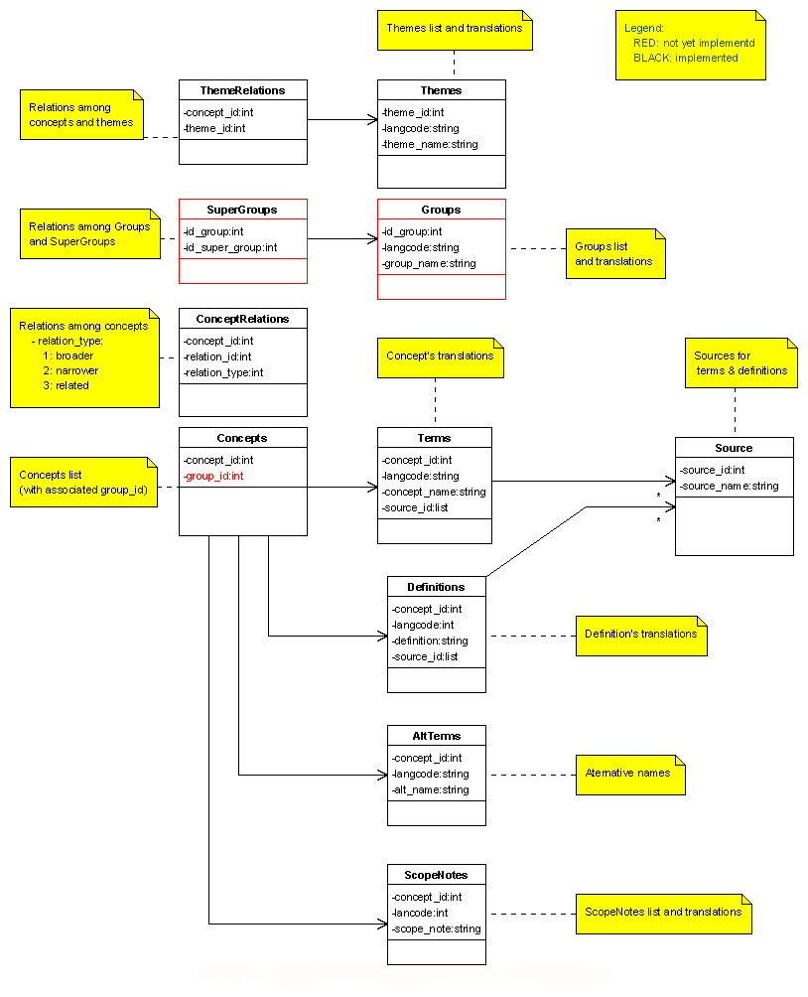
By default, the EMWIS portal and toolkit will have a default thesaurus uploaded. Other thesauri can be added from the Zope Management Console by Manager users. This is done by selecting the metatype ‘Naaya Thesaurus’.
Inside each NaayaThesaurus instance the following objects will be automatically created:
- alt_terms (Data module for alternative terms)
- concept_relations (Data module for concept relations)
- concepts (Data module for concepts)
- definitions (Data module for definitions)
- scope_notes (Data module for scope notes)
- source (Data module for sources)
- terms (Data module for terms)
- theme_relations (Data module for theme relations)
- themes (Data module for themes)
- thesaurus-labels.rdf (Customisable Python Script for export of labels and definitions in RDF/SKOS format)
- thesaurus-relations.rdf (Customisable Python Script for export of concept relations in RDF/SKOS format)
- thesaurus-themes-labels.rdf (Customisable Python Script for export of theme labels in RDF/SKOS format)
- thesaurus-themes-relations.rdf (Customisable Python Script for export of themes relations in RDF/SKOS format)
- thesaurus_catalog (Thesaurus catalog used for searching and indexing multilingual content)
- thesaurus_css (Customisable Page Template containing the thesaurus Cascade Style Sheet)
The data inside the thesaurus is linked with complex relations, thus an order is required on adding information in order to maintain its consistency. (e.g. one cannot insert a theme translation for a given theme id if that theme id does not exist). After adding data, consistency checks are done on edit and delete of records.
Each data module contains the:
- ‘Properties’ tab from where Managers can set the title of the data module (this property is reflected only on Zope Management Interface)
- ‘Management’ tab from which you can handle the data stored inside (add/edit/delete)\
- ‘Statistics’ tab where Managers can see information related to its data
- ‘Undo’ tab from where you can undo any action you made on the current object.
- ‘Import’ tab (only where relevant) that was implemented for bulk upload, XML-based (SKOS/RDF format expected).
Concepts module
This is the first module to be filled with data. Managers can manually add from 'Management' tab or import a XML from the Import tab. One can freely add/import any concept ids, no constraints are put on this module for the on add operation. From the Management tab only a value for the concepts id is required (e.g. 77) on add.
From the Import tab, a XML in RDF/SKOS format should be specified, containing a structure like:
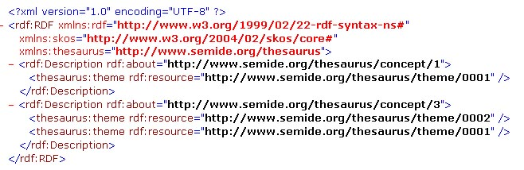
Upon import, two concepts with the ids '1' and ‘3’ will be added in the Concepts module and three theme-relation records, the first being concept id '1', theme id '0001' will be added in the Theme Relations module. A concept should belong at least one theme. After import, an information message will be displayed like below:
File imported successfully.
Concepts added: 2
ThemeRelations added: 3
which informs the user about the data actually added. If the imported XML if broken no actions will be done and the following message will be displayed:
Errors: Parsing error. The file could not be parsed.
Theme Relations module
This module does not contain an 'Import' tab since the relevant data is imported from the Concepts module. Assuming the previous example XML was loaded, 3 records should be found here on the Management tab. Furthermore, Managers can add individual records based on the concept ids from the Concepts module.
When trying to add a non existing concept id, an error message will be displayed informing users that the concept id does not exist so no relation can be defined.
Adding e new (unique) theme id will result in creating a new theme. No constraint on the theme id field is imposed.
Themes module
On this module the themes translations are stored; the Management tab allows users to select a theme id and translate it in each available language.
From the Import tab, Managers can import data using XMLs with the structure described below:
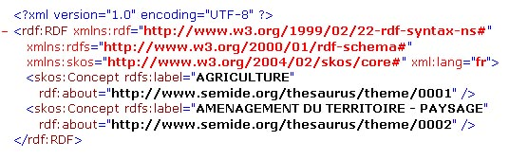
Importing the file above will result in adding the French translations for the existing themes with ids 0001 and 0002.
On Import tab, a language combobox is present, which should be used to manually select a language for translations in case that is not clearly specified in the XML file (e.g. xml:lang="fr"); if the language is correctly specified in the XML, the selection on the form is ignored. This rule applies to all language combos found on Import tabs on the other modules.
Concept Relations module
On this module the relations among concepts (e.g. broader, narrower and related) are defined. The constraint defined on adding is for the ‘concept_id’ and 'relation id'’ fields to exist. The consistency of the relations added (e.g. you can make a concept be broader and narrower to the same concept) is the user’s responsibility.
On the Import tab you should provide an XML with the structure described below: 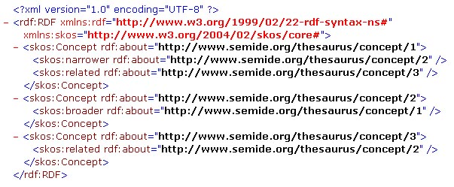
Such file will import four relations.
Terms module
From here Managers can add concepts’ translations and their associated source ids.
From the Import tab XML files can be imported if these have a structure like:
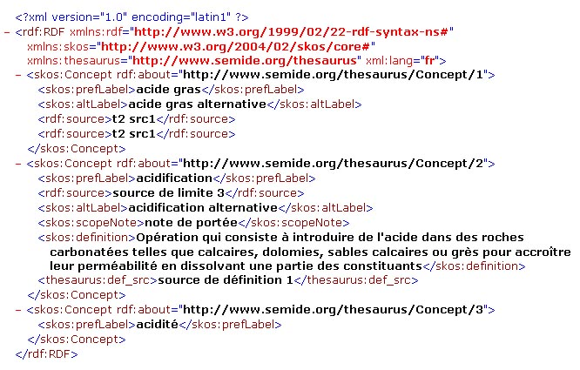
Importing this XML will result in adding 3 concepts’ translations, one alternative translation, one definition, one scope note and four sources, all in French.
Alternative Terms, Definitions, Scope Notes and Source modules
None of these modules have an Import tab, the data for them will be imported via Terms module -> Import tab. All the data for these modules is related to the concept description and can be added from the corresponding Management tabs.
Delete/Update constraints and triggers
On the Theme Relations and Concepts modules there are constraints/triggers on delete and edit. On the Theme Relations for example, deleting all records that make reference to a theme id will automatically trigger the deletion of all its translations from Theme module. Also deleting all references of a concept to any theme id will display a warning that informs users that a concept was left without any theme association.
Similarly, when deleting a concept from the Concept module, all its references from Concept Relations, Terms, Definitions modules … etc will be automatically deleted.
End user views
Two views are available for the content – thematic and alphabetical. Later, when groups and super groups will be added to this structure, a hierarchical listing can be also created.
The thematic listing starts from the lists of themes from which end users can reach concepts and allows navigating through among them using the relations (narrower, broader, related term).
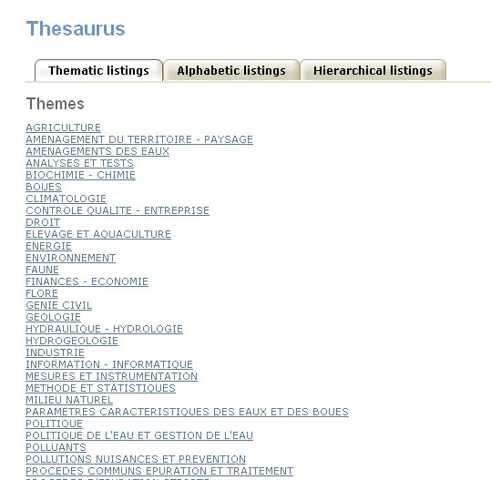
Thematic listing of the thesaurus
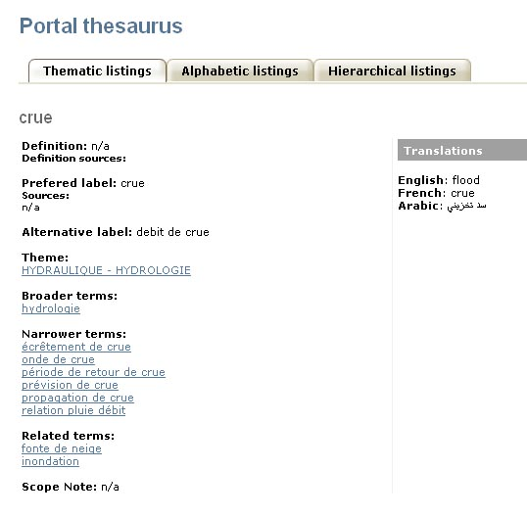
View of a thesaurus concept

The alphabetical listing arranges all concepts and terms according to their first letter of the translation in the selected language. The English, French and Arabic alphabets have been implemented.
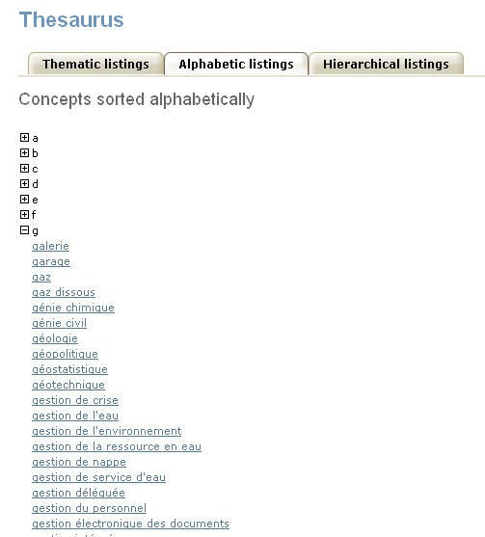
Alphabetic listing of the thesaurus
Overview of functionalities that NaayaThesaurus will expose:
- import from SKOS in one language at the time
- export in SKOS in one language at the time
- alphabetical display of concepts for the picklists
- thematic view (navigation from the website)
- alphabetic view (navigation from the website)
- add/edit/delete/translate of single entity (theme, concept, term, relation) - all properties available for each one can be modified (translated). It will be possible to even modify (add, edit, delete) the relations schema.
- translation centre - a friendly web form will display all entities (e.g. 10 per page) showing the translation status in all languages, with a link to the individual translation form

Notifications on uploads and newsletters
The ChangeNotification (http://svn.eionet.eu.int/repositories/Zope/trunk/ChangeNotification/) Zope product will be used to allow subscribers to register to different topics (folders) from the website and receive email notifications on new uploads in those topics.
This component will be modified in order to allow using user accounts from the entire website (currently separate accounts are stored inside a notification folder), which will provide a Single Sign-On service – once authenticated, users can execute a wider set of operations in the website using the same account:
- Create an account (username, password for authentication and name, email address for future reference);
- Set the favourite portal page as welcome page;
- Apply for content contribution rights;
- Participate in the forum;
- Receive a monthly newsletter (electronic Flash) which is automatically aggregated by the system from the news and events (and other data types, configurable by administrators) published in that period;
- Subscribe to the website’s push service based on choosing the preferred topics from where he/she will be notified on new content and/or keywords that the for which they will be notified should contain.
ChangeNotification will store extra-attributes for each user for all the above services and, upon authentication, the user will see a preferences page from which he/she will be able to change all the settings previously set (account information, welcome page, whether or not to receive the newsletter, topics and keywords that filter the upload notifications).
This system uses a maildrop mechanism which is separated from the Zope server so, in case of an increased number of subscribers, the mail sending process will not burden the server.

Discussion forum
Two Zope products will be installed and configured on the demo portal for EMWIS for evaluation: fcForum (http://www.zope.org/Members/speedbird/) and MessageBoard (http://svn.eionet.eu.int/repositories/Zope/trunk/MessageBoard/). Both of them allow threaded discussions on topics, from the more complex approach of fcForum up to the simpler one of MessageBoard.
After choosing the one closer to the EMWIS needs, it will be modified to fully fit the requirements if necessary and this version will be present on the demo EMWIS website and distributed along with the toolkit.

Access statistics
In order to effectively manage a web server, it is necessary to get feedback about the activity and performance of the server. Almost every http server (including Apache or Medusa) keeps the tracks of all the visited pages, of all the requests processed by the server, of users that accessed some resources or the source IP addresses. Apache's Web logging features are flexible for a single website or for managing numerous domains requiring web log analysis. There are many applications that, starting from the log files, can be used to offer meaningful statistics about the pages visited, hits, users, busiest hours, and so on.
Here are just some examples of some open-source log analyzer tools:
- Webalizer (http://www.mrunix.net/webalizer/ )
- AWStats (http://awstats.sourceforge.net)
By default, in Zope.2.7.x the logs are kept in the "log" folder, inside the Zope instance directory. The access log (default named "Z2.log") records every request made to the HTTP server. It is recorded in the Common Log Format.
The zope.conf file of the zope instance is used to set up the level of logging and the path to the log file. The default settings can be changed in the logger section, in the "<logger access>" directive, of the zope.conf file. If the path is an empty string, no logging will be done.
If Zope's web pages are reached by users through another HTTP server (usually Apache), Apache’s logs can be used instead.

Expected results
The software deliverables will be presented on an on-line website publicly accessible on the Internet throughout the entire development and testing phase. The fist release will be made on a demo server installed at Finsiel premises, after which the server will be installed and configured at EMWIS premises following the instructions given by the Finsiel team. Such server will be updated as needed, at least when releases are foreseen or modifications are brought as result of comments and feedback coming from stakeholders.

Portal toolkit
After the acceptance of the portal software installed on a demonstration website, the components will be documented and packed along with installation and getting started instructions.
Friendly installation procedures will be built for Windows XP and 2003 and Linux Fedora 2, based on a few forms that gather custom information from users and resulting in the creation of an EMWIS-compliant portal with all functionality integrated and ready to be filled with content.
Because such portals require a few operations running on regular basis (e.g. updating the remote channels of information, sending newsletters to subscribers), the necessary cron jobs will be set up by administrators using a task scheduler from the operating system, according to the instructions given by the toolkit documentation.
Also, the program for access statistics will be installed and managed by local system administrators and not done automatically by the installation package.

Operating environment
The portal software will be tested in Windows (XP, 2003) and Linux (Fedora 2) environments. The installation instructions delivered with the software will however apply for all platforms supported by Python and experienced system administrators will be able to download the source code and documentation and create their portals on those operating systems.
The behaviour of the portal must not change according to the operation system, at least when Windows and Linux are concerned. When outside modules which Naaya uses in order to achieve certain functionality are not available in full on some operating systems, it will be the task of the local system administrator to replace or decide to renounce offering that feature for the portal. Finsiel will document this possible incongruence and warn about it in the installation instructions. However, the choices for using outside components will be made in such way to ensure the basic functionality (e.g. data types, content management, navigation and accessibility) exists and remains the same on most operating systems.
The most common example for the above-mentioned incongruence is the use of conversion programs from .PDF, .DOC, .XLS, .PPT into text, which are usually available for most operating systems as open source. The local search mechanism only indexes those types of files uploaded in the portal for which a converter is available and ignores the rest.

Software updates and maintenance
Throughout the entire development time, the latest version of the source code of all Zope products created or modified by Finsiel and used to build the portal architecture will be available on SVN repositories as follows: http://svn.eionet.eu.int for software components that belong to EEA and http://svn.finsiel.ro for the custom developments for EMWIS.
At the end of the current contract, the final version of all source code will be delivered as archives or moved to an appointed SVN repository as indicated by EMWIS.
After the end date of the contract, all future modifications of the code due to bug fixing will result in updates of the final delivery of source code or direct updates on a SVN repository if that will be the case. All bug fixes will be applied to the running portals by Finsiel after necessary tests will be performed on a local Finsiel installation.

User documentation
A user guide for all actors involved in the portal administration (administrators, content contributors, translators, etc.) will be available in HTML format and linked to each portal installed. The guide will describe the operations that can be executed by each type of user and the way to reach the corresponding user interfaces through which each function is achieved.
The user documentation will be the same for the central EMWIS portal and all local installations and will be delivered with the portal toolkit.
The documentation will be delivered in English.

Technical documentation
For all software components (Zope products) used to build the EMWIS portal and portal toolkit, HTML documentation of the Python classes and their functions will be generated upon conclusion of the contract.
Generic instructions on how to find and install a Zope component that might be needed to add extra-functionality not provided by the portal toolkit will be written for technical people.
Moreover, the necessary instructions for the system administrators to set up and maintain their portals built using these tools will be delivered.
The technical documentation will be the same for the central EMWIS portal and all local installations and will be delivered with the portal toolkit.
The documentation will be delivered in English.

Databases interoperability (Oracle, MySQL, PostgreSQL…)
Zope uses an internal object database (ZODB) for data storing. Although large number of objects can reside in this database hierarchically arranged, there are cases where external relational databases have to be used and Python products have to be written for interfacing their data with the necessary web forms.
Such cases usually involve relational data which will be hard to replicate by building Python classes to handle it or external databases used by other applications as well.
For such purposes, a document will be written explaining what is involved in creating Python products to query and display the data using the Zope-based portal. References of already existing applications of such type will be given and links to documentation for programmers will be provided.

System maintenance & user support
These operations will be done by Finsiel for a period of 1 year from the end date of the contract, based on requests coming from EMWIS.
A helpdesk ticketing product will be installed at Finsiel’s premises and published on a public web address to be used by the EMWIS community when reporting problems or asking for help. Each issue posted on the helpdesk has a unique ticket number and will be followed by an appointed Finsiel team until a suitable solution is found to conclude it. This HelpdeskAgent component (http://svn.eionet.eu.int/repositories/Zope/trunk/HelpDeskAgent) is successfully used for similar operations by the EC CHM community.
Corrective operations will be done to the software in order to ensure the good functioning of the systems when these problems arise from software bugs or differences from the approved specifications.

